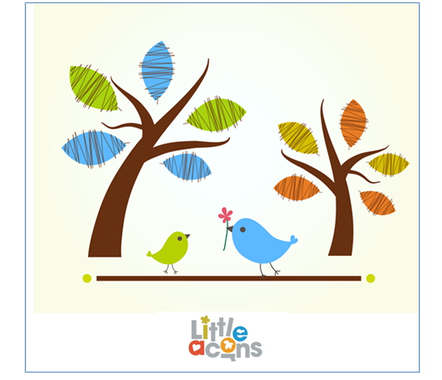

Sickness Policy

I will request that parents give me written permission to seek emergency medical advice/treatment for their child before accepting a placement.
Should a parent decline to give me written permission to seek emergency medical advice/treatment, then I will not accept their child for placement in my care.

Children with Illness

Before being dropped off, parents are required to advise me if their child is feeling unwell or has been unwell within the previous forty eight hours.
I will discuss with the parent the circumstances of the illness and will advise the parent if I am prepared to care for the child that day or not.

Children’s Falling Ill Whilst In My Care

Should a child in my care fall ill I will immediately telephone their parent to discuss the child’s illness and if necessary to arrange collection of the child immediately.
Should I not be able to get in touch with a parent then I will telephone the emergency contact(s) to discuss the illness and/or arrange for them to collect the child if it is stated on the child’s Child Record Form that they are a person who may collect the child.
Whilst waiting for a parent or emergency contacts to collect the child I will ensure she/he is made as comfortable as possible.

I will ensure that the effected child is kept away from other children where possible.

Only in exceptional circumstances would I seek emergency medical advice/treatment without first making contact with a parent of the child or an emergency contact.

Exclusion of a Child with an Infectious Illness

I will require that children with an infectious illness are kept away for the minimum period required for that particular illness, as advised by the child’s doctor. If I consider it appropriate I will require written evidence of this from the child’s doctor.

Children who have shown signs of diarrhoea and/or vomiting will excluded for 48 hours after the last occurrence in line with Department of Health advice. (Please see table A below).
I will inform parents of children who might have come into contact with an infectious disease whilst in my care of this fact, however, I will attempt to maintain confidentiality as much as possible.

Hygiene

I ensure all adults and children in my setting are aware of good hand-washing procedures, before eating or handling food and after using the toilet.

I will to provide a face flannel and towel [with name tags] for their child, which I wash regularly.
I ensure there is a supply of tissues available for children.
I immediately clean up any spillage of body fluids using a disposable cloth and gloves.
I wear disposable gloves for changing nappies. I will discard these gloves after each change.
I will disinfect the changing mat after each change.

Notification to Ofsted

I have a duty to advise Ofsted of any episodes of food poisoning affecting two or more children I care for.

As far as practicable I will advise parents prior to notifying Ofsted, but may not be able to do so in all cases.

Notification to Health Protection Agency

I have a duty to advise Health Protection Agency of any infectious diseases of the Notifiable Disease contracted by children in my care.

As far as practicable I will advise parents prior to notifying Health Protection Agency, but may not be able to do so in all cases.

Exclusion Periods - Guidance on infection control in schools and other childcare settings (Table A).

Rashes and skin infections | Children with rashes should be considered infectious and assessed by their doctor.
Athlete’s foot | None
Chickenpox | Until all vesicles have crusted and when the child feels well without a temperature present
Cold sores, (Herpes simplex) | Until treatment has started
German measles (rubella)* | Six days from onset of and when the child feels well without a temperature present
Hand, foot and mouth | Five days from the last outbreak and when the child feels well without a temperature present
Impetigo | Until lesions are crusted and healed, or 48 hours after starting antibiotic treatment
Molluscum contagiosum | None
Measles* | Four days from onset of rash and when the child feels well without a temperature present
Roseola (infantum) | None
Ringworm | Exclusion not usually required
Scabies | Child can return after first treatment
Scarlet fever* | Child can return 24 hours after starting appropriate antibiotic treatment and when the child feels well without a temperature present
Slapped cheek/fifth disease. Parvovirus B19 | None (once rash has developed) and when the child feels well without a temperature present
Shingles | Exclude only if rash is weeping and cannot be covered or until all vesicles have crusted
Warts and verrucae | None
Diarrhoea and vomiting illness

Diarrhoea and/or vomiting | 48 hours from last episode of diarrhoea or vomiting
E. coli O157 VTEC Typhoid* [and paratyphoid*] (enteric fever) Shigella (dysentery) | Should be excluded for 48 hours from the last episode of diarrhoea. Further exclusion may be required for some children until they are no longer excreting
Cryptosporidiosis | Exclude for 48 hours from the last episode of diarrhoea
Respiratory infections

Flu (influenza) | Until recovered
Tuberculosis* | Always consult your local PHE centre
Whooping cough* (pertussis) | Five days from starting antibiotic treatment, or 21 days from onset of illness if no antibiotic treatment
Other infections

Conjunctivitis | None
Diphtheria * | Exclusion is essential. Always consult with your local HPT
Glandular fever | None and when the child feels well without a temperature present
Head lice | Until treatment has started
Hepatitis A* | Exclude until seven days after onset of jaundice (or seven days after symptom onset if no jaundice)
Hepatitis B*, C*, HIV/AIDS | None
Meningococcal meningitis*/ septicaemia* | Until recovered
Meningitis* due to other bacteria | Until recovered
Meningitis viral* | Until recovered
MRSA | None
Mumps* | Exclude child for five days after onset of swelling and when the child feels well without a temperature present
Threadworms | None
Tonsillitis | None

* denotes a notifiable disease. It is a statutory requirement that doctors report a notifiable disease to the proper officer of the local authority (usually a consultant in communicable disease control). In addition, organisations may be required via locally agreed arrangements to inform their local PHE centre. Regulating bodies (for example, Office for Standards in Education (OFSTED)/Commission for Social Care Inspection (CSCI)) may wish to be informed – please refer to local policy.

